 | Year 5 - Long Term Reading Overview
 | Autumn |  | Spring |  | Summer
Text/s | Kensuke’s Kingdom – Reading Challenge  We chose this as it explores being strong-minded, survival skills and explores characters challenges, which will allow us to focus on retrieval and interpret and fits with the modern world of new scenarios. | Percy Jackson – Reading Challenge  We chose this book as he finds out his uncle is a Greek God which will provide the chn with new vocabulary for their Myths in English. A strong focus on interpret as Percy experiences a range of emotions towards his uncle and will allow the chn to explore different language choices. | Pig Heart Boy – Reading Challenge  (heart transplant from a pig)  We chose this book as a stand alone text as it focuses on empathy and has an interesting choice of language and explores a range of feelings about transplants which will be a new concept for the children as well as new vocabulary to match the explain skill. | Holes – Reading Challenge  We chose this book as a stand alone text as it focuses on the main character who has been treated unfairly and explores his emotions throughout his hardship. Great for interpret as it focuses on characters actions and expressions as well as interactions with others. | Harry Potter –  Reading Challenge  We chose this book as a stand alone text as it uses a range of interesting vocabulary for the chn to explore, and explores a range of themes including: friendship, loss and loyalty, which will allow the chn to interpret different emotions in different fantasy scenes. | Private Peaceful – Reading Challenge  We chose this book as it heavily links to WW2 and deals with loss, friendship and love. This book uses a range of war time/historical language which will help the chn to understand the theme of local History, specifically focusing on the Galton family who used to make and provide weapons for WW2.
Poetry | The River – Valerie Bloom  This poem is a free verse about rivers which will be explored in English. It compares the river to a person and how unsettled they are – will allow chn to explore deeper thinking skills. | The Olympians - R.W. A Mad Poet  A greek poem which uses a range of interesting vocabulary to describe the Gods, each stanza explores a different personality trait which will allow the chn to make comparisons and draw on differences. | Structured poetry –  Ancient Egypt  An Egyptian poem which uses historical language, is informative so will allow the chn to retrieve and will add to their subject knowledge. Also, we can explore how the Poet feels about different Egyptian aspects linked to the time such as mummification. | Structured poetry –  Easter  This poem is a structured Limerick which will be explored in English. It focuses on Easter which links with our R.E. unit and uses difficult vocabulary for the children to explore and excellent for retrieval. | Reading Explorers – Colour Blind  This poem explores the idea of the unknown which fits with the idea of an unknown world up in space and will help the chn with their English unit, writing a Sci-Fi narrative. The poet uses interesting vocabulary to describe a range of colours in interesting ways which will allow the chn to explore different choices of language. | Narrative Poetry – The adventures of Isobel  This poem is a narrative poetry which will be explored in English. We will explore all of the skills as the main character Isobel meets a range of interesting characters who are extremely different to her, which will allow the children to interpret different characters and compare their feelings.
Skills Focus | Retrieve  Interpret | Retrieve  Interpret  Choice | Retrieve  Interpret  Choice  Explain | Retrieve  Interpret  Explain | Retrieve  Interpret  Choice  Explain | Retrieve  Interpret  Choice  Explain
Theme | A Wonderful World – Rivers, Mountains and Hills | Peace and Conflict –  Ancient Greece | A Moment in Time –  The Egyptians | Nurturing Nature –  Bees | We are Engineers –  Space | Our Place in the World-  Local History
Other theme Linked Texts/images/video to use as extracts | Extracts:  Reading Explorers: Volcanoes  Reading Explorers: The North Wind Doth Blow  Reading Explorers:  Avalanche  Once upon a picture: Drifting Away  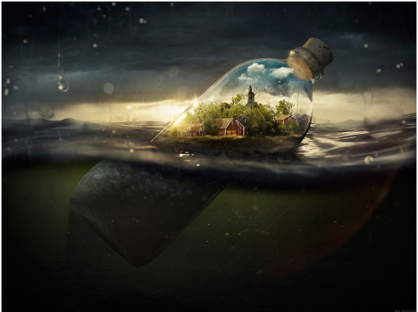  Rescue from the Storm  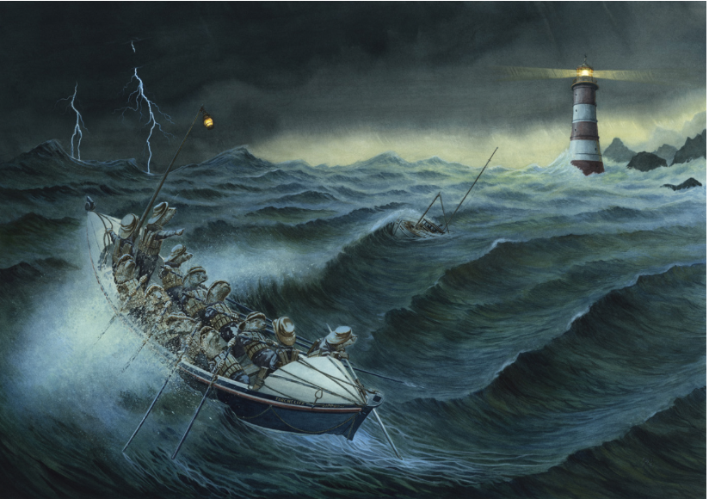 | Extracts:  Reading Explorers: Wolf man  Once upon a picture:  The Prince and the Serpent  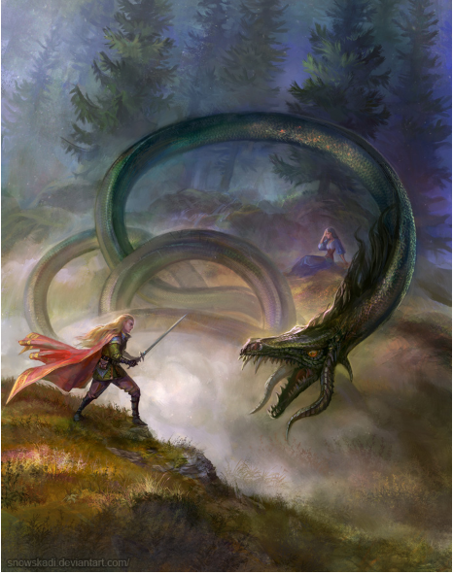 | Extracts:  Reading Explorers – The tale of two cooking pots  Reading Explorers – I want my mummy  Reading Explorers – The Quest (playscript link)  Once upon a picture:  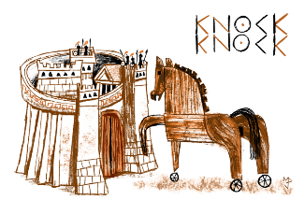  Trojan Horse  The Tomb of the Emerald  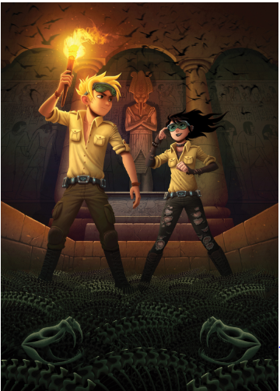 | Extracts:  Reading Explorers- Magpie Girl  Once upon a picture:  Never travel alone | Extracts:.  Reading Explorers:  Space Attack  Once upon a picture  Moon ladder  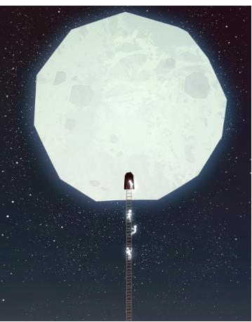  Spirit Animal  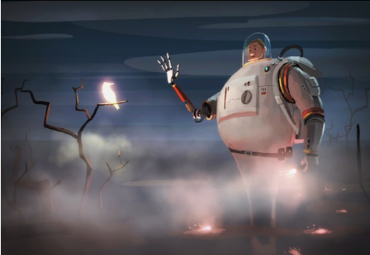  Melvin the sad-ish robot  Something familiar  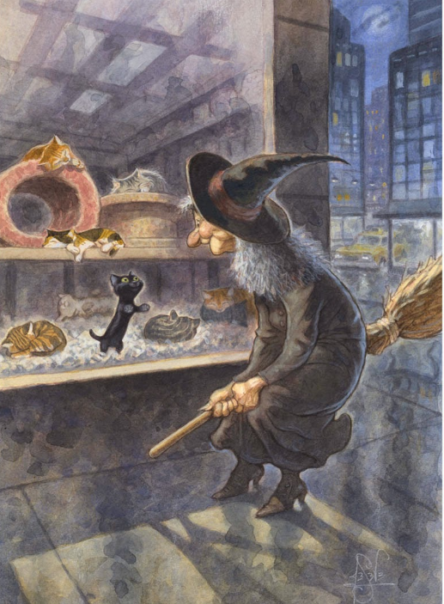 | Extracts:  Reading explorers – Cragowrth cottage  Reading Explorers - Houdini Does it Again  Once upon a picture:  The Loss of time  Walk Away  Propaganda

AUTUMN 1: Non-Chronological Report | SPRING 1: | SUMMER 1:
AUTUMN 2: | SPRING 2: | SUMMER 2:

